Institute of Computer Technology

B. Tech Computer Science and Engineering

Subject: DS (2CSE302)

**PRACTICAL-6**

**AIM: - To learn applications of recursion in real-life scenario.**

**6. The Fibonacci appears in the smallest, to the largest objects in nature. It is a way for information to flow in a very efficient manner. The number of petals in a flower consistently follows the Fibonacci sequence. Famous examples include the lily, which has three petals, buttercups, which have five, the chicory's 21, the daisy's 34, and so on.**

1. **Flowers of all kinds follow the pattern, but roses are most favourite kind to use as an example of the Fibonacci Sequence. The petals unfold more & more and the sequence increases for the best possible exposure to sunlight and other factors. There is a rose flower (as shown in Figure), which is having only 9 petals. So, Write the c program to print fibonacci series till Nth term (9th petal) using recursion.**

**Hint: N=9**

* + **Input: Enter number of terms in Fibonacci series: 9**
  + **Output: Fibonacci series till 9 terms**

**0 1 1 2 3 5 8 13 21**

***SOLUTION***

#include<stdio.h>

void fibonacci(int num)

{

static int n1=0,n2=1,n3;

if(num>0)

{

n3 = n1 + n2;

n1 = n2;

n2 = n3;

printf("%d ",n3);

fibonacci(num-1);

}

}

int main()

{

int yash;

printf("Enter the number of elements: ");

scanf("%d",&yash);

printf("Fibonacci Series: ");

printf("%d %d ",0,1);

fibonacci(yash-2);

return 0;

}

***OUTPUT***

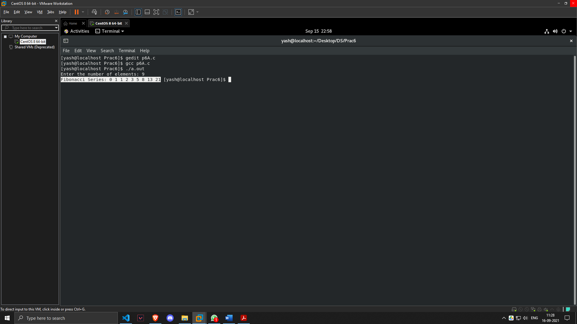

1. **Tower of Hanoi is a mathematical puzzle where we have three rods and n disks. The objective of the puzzle is to move the entire stack to another rod, obeying the following simple rules:** 
   * **Only one disk can be moved at a time.**
   * **Each move consists of taking the upper disk from one of the stacks and placing it on top of another stack i.e. a disk can only be moved if it is the uppermost disk on a stack.**
   * **No disk may be placed on top of a smaller disk.**

**Write the c program for Tower of Hanoi using recursion.**

**Hint:**

* **No of Disk =3 and no. of rod = 3**
* **Take an example for 2 disks :**

**Let rod 1 = 'A', rod 2 = 'B', rod 3 = 'C'.**

**Step 1 : Shift first disk from 'A' to 'C'.**

**Step 2 : Shift second disk from 'A' to 'B'.**

**Step 3 : Shift first disk from 'C' to 'B'.**

**The pattern here is :**

**Top Disk moved from A to C**

**Top Disk moved from A to B**

**Top Disk moved from C to B**

**Input: Enter the Number of Disks: 3**

**Output :**

**Top Disk moved from A to B**

**Top Disk moved from A to C**

**Top Disk moved from B to C**

**Top Disk moved from A to B**

**Top Disk moved from C to A**

**Top Disk moved from C to B**

**Top Disk moved from A to B**

***SOLUTION***

#include <stdio.h>

void TOH(int n, char a, char b, char c)

{

if (n > 0)

{

TOH(n - 1, a, c, b);

printf("\nTop Disk moved from %c to %c ", a, b);

TOH(n - 1, c, b, a);

}

}

int main()

{

int yash;

printf("\nEnter the Number of Disks: ");

scanf("%d", &yash);

TOH(yash, 'A', 'B', 'C');

printf("\n\n");

}

***OUTPUT***

